Console example – list of available commands

All references in this document refer to document DPA Framework Technical Guide v.3.00

List of commands:

- rst - print header of Console command processor
- ls - list of files in root directory of SD card

- bond - see chapter 3.2.6 Bond node
- bond „RegAddr“ „BondingMask“ - see chapter 3.2.6 Bond node ( parameters „RegAddr“ and „BondingMask“ are not obligatory )
- bond get - see chapter 3.2.4 Get bonded nodes ( result of this command is map of bonded nodes. You can see it on the next picture )

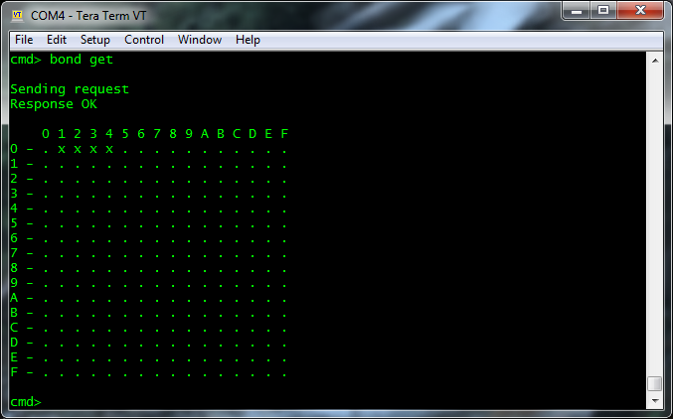

- bond clear - see chapter 3.2.5 Clear all bonds
- unbondc „BondAddr“ - see chapter 3.2.7 Remove bonded node
- rebondc „BondAddr“ - see chapter 3.2.8 Re-bond node
- discovery - see chapter 3.2.9 Discovery
- discovery „TxPower“ „MaxAddr“ - see chapter 3.2.9 Discovery ( parameters „TxPower“ and „MaxAddr“ are not obligatory )
- discovery get - see chapter 3.2.3 Get discovered nodes
- ledr on „NADR“ - see chapter 3.9.2 Set
- ledr off „NADR“ - see chapter 3.9.2 Set
- ledg on „NADR“ - see chapter 3.9.2 Set
- ledg off „NADR“ - see chapter 3.9.2 Set
- ledr get „NADR“ - see chapter 3.9.3 Get.
- ledg get „NADR“ - see chapter 3.9.3 Get
- ledr pulse „NADR“ - see chapter 3.9.4 Pulse
- ledg pulse „NADR“ - see chapter 3.9.4 Pulse

Example how to use some commands of peripherals LEDs, you can see on next picture.

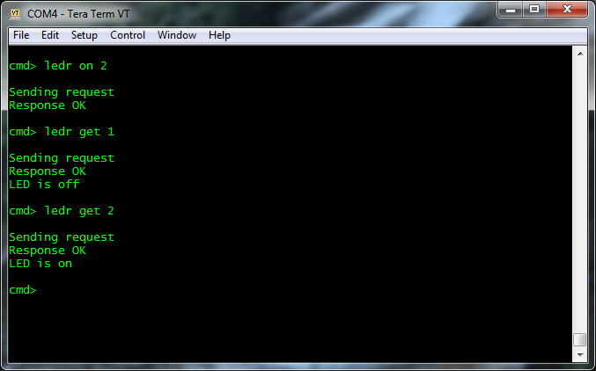

- unbondn „NADR“ - see chapter 3.3.3 Remove bond
- osreset „NADR“ - see chapter 3.4.3 Reset
- osrestart „NADR“ - see chapter 3.4.4 Restart
- osinfo „NADR“ - see chapter 3.4.2 Read. ( example to this command, you can see on next picture )

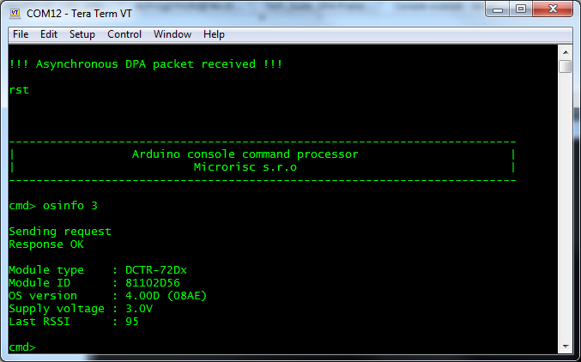

- loadcfg „filename“ „NADR“ - see chapter 3.4.6 Write HWP configuration

- Command is used for uploading new configuration to selected TR module. Configuration files must be prepared in root directory of SD card, which is connected to an Arduino board. To create a new configuration file, we use the IQRF IDE. The configuration file will have an extension *.trcnfg. As the library to work with SD card does not support long file names, we should rename the configuration file to match the format 8.3. For example config1.cfg, conf.trc ….

- Command parameters have the following meanings:

-filename - name of configuration file. The name should be in 8.3 format.

-NADR - address of destination TR module

The next set of commands is possible to use only, if the #define __STORE_CODE_SUPPORT__ is enabled in dpa_library.h file.

- storecode „filename“ „eeeadr“ „NADR“

- Command is used for uploading the code image of HEX or IQRF file. Code image is uploaded to selected address in eeeprom memory of TR module. HEX or IQRF files must be prepared in root directory of SD card. As the library to work with SD card does not support long file names, we should rename the HEX or IQRF files to match the format 8.3.

- Command parameters have the following meanings:

-filename - name of HEX or IQRF file. The name should be in 8.3 format.

-eeeadr - absolute address in eeeprom memory of selected TR module. Address is entered in HEX format and must be a multiple of 64.
-NADR - address of destination TR module

Example how to use this command, you can see on next picture.

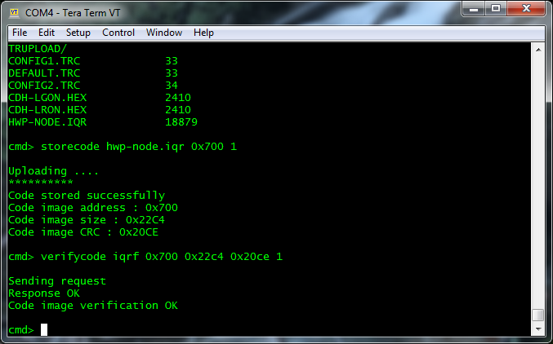
- verifycode „imgtype“ „eeeadr“ „imgsize“ „imgCRC“ „NADR“

- Command is used for verifying the code image of HEX or IQRF file, in previous step uploaded to eeeprom memory of TR module. See chapter 3.4.12 LoadCode

- Command parameters have the following meanings:

      - imgtype - type of uploaded code image. Enter hex in case of HEX file, or iqrf in case of IQRF file

      - eeeadr - absolute address in eeeprom memory of selected TR module. Address is entered in HEX format (e.g. 0x700) and it is a result of storecode operation

      - imgsize - size of code image stored in eeeprom memory of TR module.
Size is entered in HEX format (e.g. 0x22c4) and it is a result of storecode operation

      - imgCRC - checksum of code image stored in eeeprom memory of TR module.
Checksum is entered in HEX format (e.g. 0x20ce) and it is a result of storecode operation

      - NADR - address of destination TR module

- loadcode „imgtype“ „eeeadr“ „imgsize“ „imgCRC“ „NADR“

- Command is used to burning the code image of HEX or IQRF file, to FLASH memory of microcontroller in TR module. See chapter 3.4.12 LoadCode

- Command parameters have the same meaning as in case of verifycode command.

Example how to use this command, you can see on next picture.

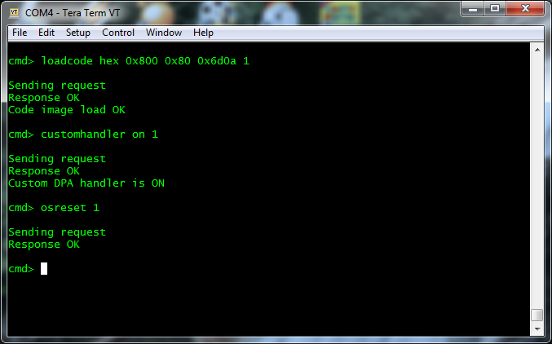

- customhandler on „NADR“

- Command is used to enable the custom DPA handler in configuration of TR-7xD module. Configuration change is applied only if the module is reset by sending of osreset command.

- customhandler off „NADR“

- Command is used to disable the custom DPA handler in configuration of TR-7xD module. Configuration change is applied only if the module is reset by sending of osreset command.

Example of good practice to update the custom DPA handler

- Use the storecode command to upload the code image of new custom DPA handler to eeeprom memory of TR-7xD module.

- Use the verifycode command to verify the integrity of code image in eeeprom memory of TR-7xD module.

- Use the customhandler off and osreset commands to disable actual custom DPA handler in TR-7xD module.

- Use the loadcode command to burn the new custom DPA handler to FLASH memory of microcontroller in TR module.

- Use the customhandler on and osreset commands to enable new custom DPA handler in TR-7xD module.

